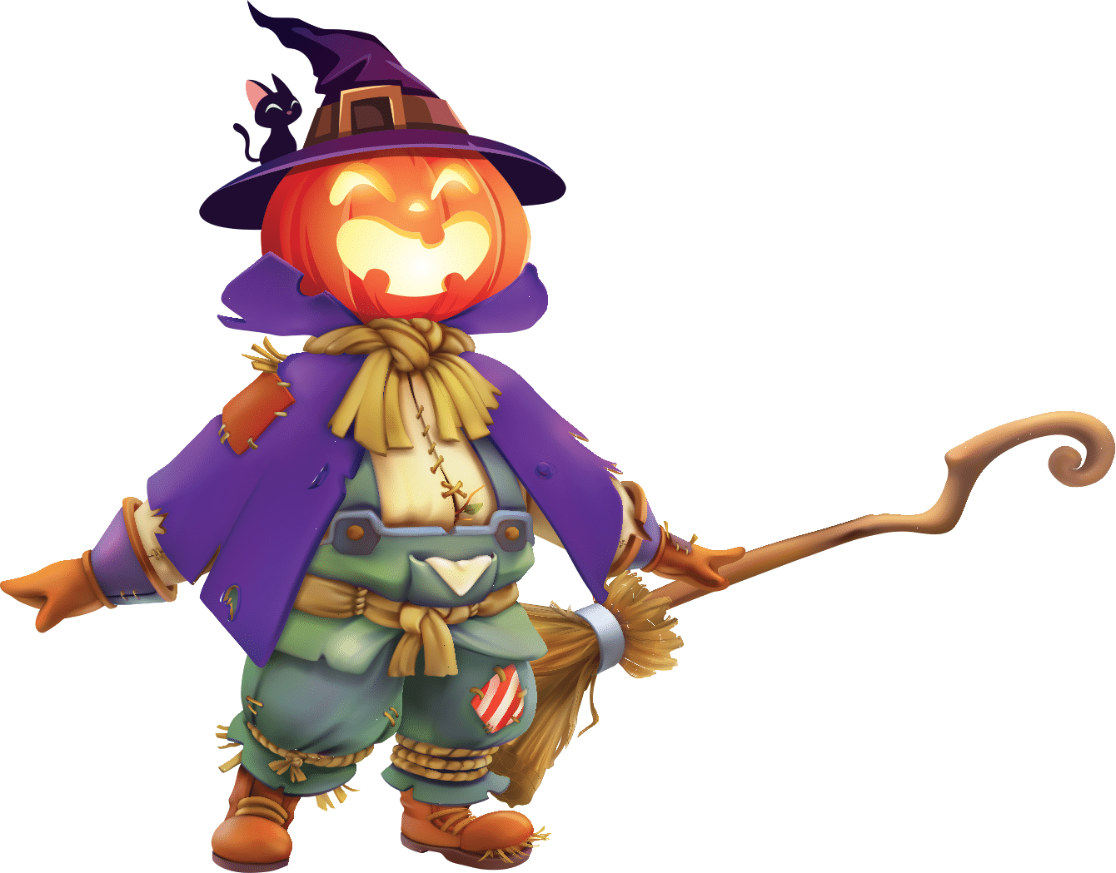
Pumpkinfest 2025
New Event: Wizard of Pumpkinfest on grounds

New Activity: Scarecrow Row – making of scarecrows to place around the fountain (by train)

Cost: $50.00 to submit for contest of best scarecrow on grounds – awards for top 3 will be “People’s Choice” Friday-Saturday 6:00 PM for 1st, 2nd, and 3rd places announced after Pumpkin Mountain lighting

Application: https://forms.gle/1bZuBfRjkQzcYv6f7
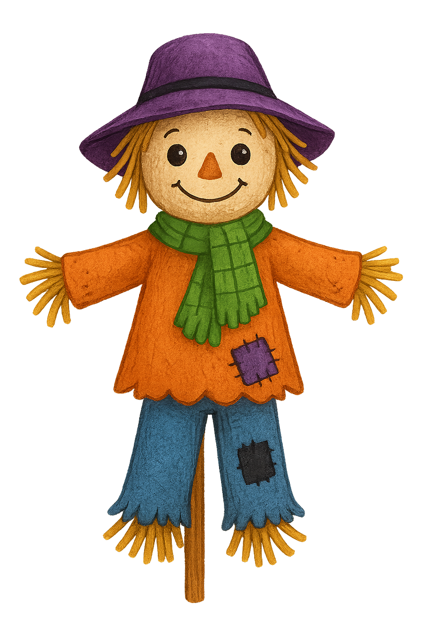
Guidelines:
- Scarecrow must be on a broom or stick
- Able to attach a zip tie to scarecrow and place on a rod to display in new Scarecrow Row in Patee Park around the fountain area
- Must have a friendly face, arms, and straw feet or similar look
- Clothing attire to be shirt, jeans, skirt, etc.
- Will be judged and juried into top 3 for People’s Choice – voting will be Friday – Saturday at 6:00 PM
- Must bring to the Museum by Thursday at 3:00 PM

